From: https://medium.com/s/making-sense/the-problem-with-nazis-8fd173f8c68

The Problem with Nazis
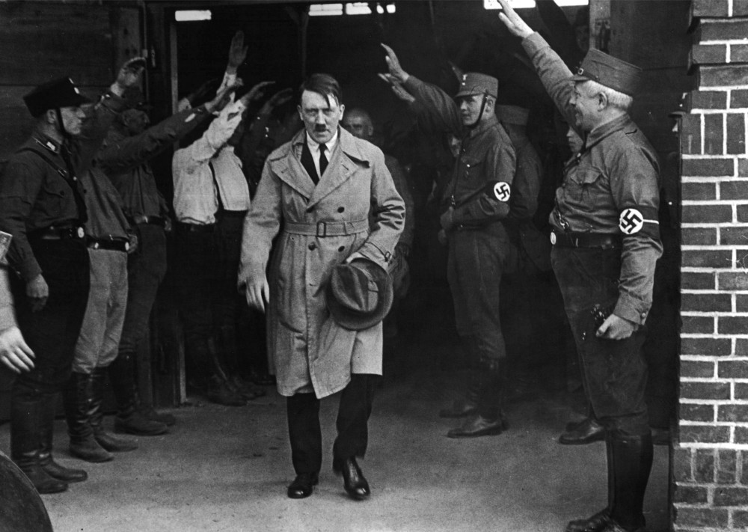
AP Images
The debate surrounding Charlottesville has become loud and complicated. Essentially everyone, except Donald Trump, David Duke, and some of Trump’s followers, has made clear that there is no moral equivalence to be made between the protestors and those who opposed them. Indeed, John McCain got it right, saying: “There’s no moral equivalency between racists and Americans standing up to defy hate and bigotry. The president of the United States should say so.”
But this hasn’t stopped a lot of ideas being bandied around about freedom of speech, the right to protest, and distinctions between racists and Nazis. Within all this argument, some basic facts risk getting lost.
What happened in Charlottesville is this: A march took place consisting of men in militia uniforms carrying guns, men dressed in KKK hoods and symbols, and men carrying Swastika flags, making the Nazi salute and shouting Zieg Hiel. One of those men drove a car into a crowd of protestors, killing one of them, an act of terrorism no different to that carried out by a right wing extremist in London recently.
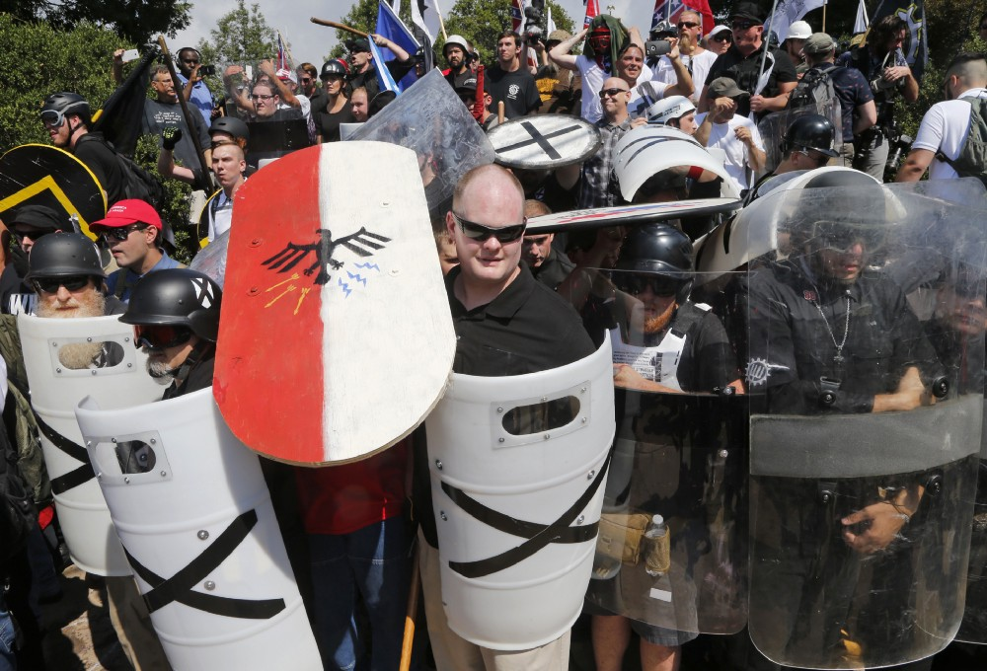
AP Images
When you join a rally and see it involves Nazis you have a simple choice: to walk away. If you are just a bigot, racist, or anti-Semite, you can still walk away when the rally includes Nazis. For any European, and it should also be the case for any American, no matter how right-wing, the Nazi symbolism should be over-stepping the mark. Anyone who did not choose to leave, instead chose to remain, walked alongside the Nazis.
The history of the 20th Century produced very few clear, indisputable lessons for mankind. One of those is that either you stand with Nazis, or you oppose them. There is no middle-ground. You can’t be bit Nazi. You’re either a Nazi, or not a Nazi. That was the essence of World War II.
Now maybe those men marching in Charlottesville were too stupid and ignorant to understand that nuance, but the rest of society, looking in and forming opinions about this should find this simple. If you choose to march in a rally with Nazis, you are a Nazi. As the War taught us (or should have done) you cannot sit passively by and refuse to take sides when it comes to Nazis. Millions of people died creating that lesson for future generations.
So the debate about Charlottesville should not be allowed to be complicated. Clearly there was no moral equivalence. However violent, disruptive, and unlawful some of the anti-Fascist protestors were, they are absolved because they were fighting Nazis. It doesn’t matter if they are left wing, Black, Jewish, or just pissed off, they were right to lose their shit — as I would have done — seeing men marching with Swastika flags. Losing our shit, the last time around, is what defeated Hitler.
There is a very clear historical precedent for Charlottesville. Back in London in October, 1936 the British Union of Fascists marched through the East End of London, which was a predominantly Jewish area. Their leader, Oswald Mosely, was a disciple of Hitler, and his Black Shirts were the ideological cousins of the German Nazis.
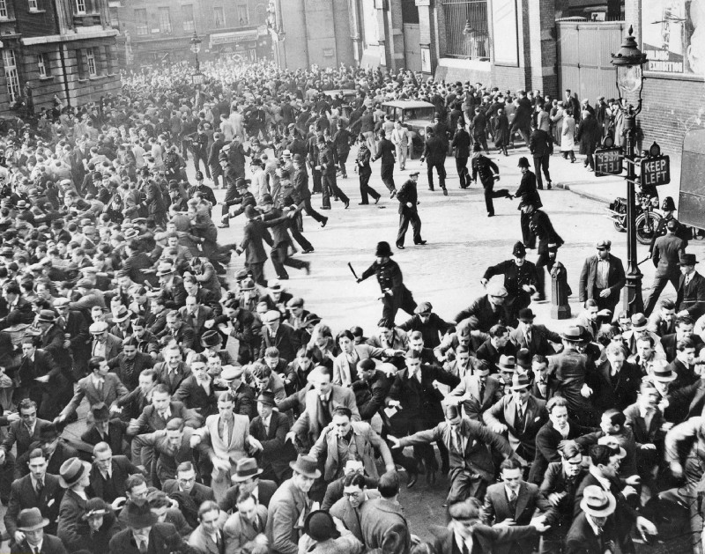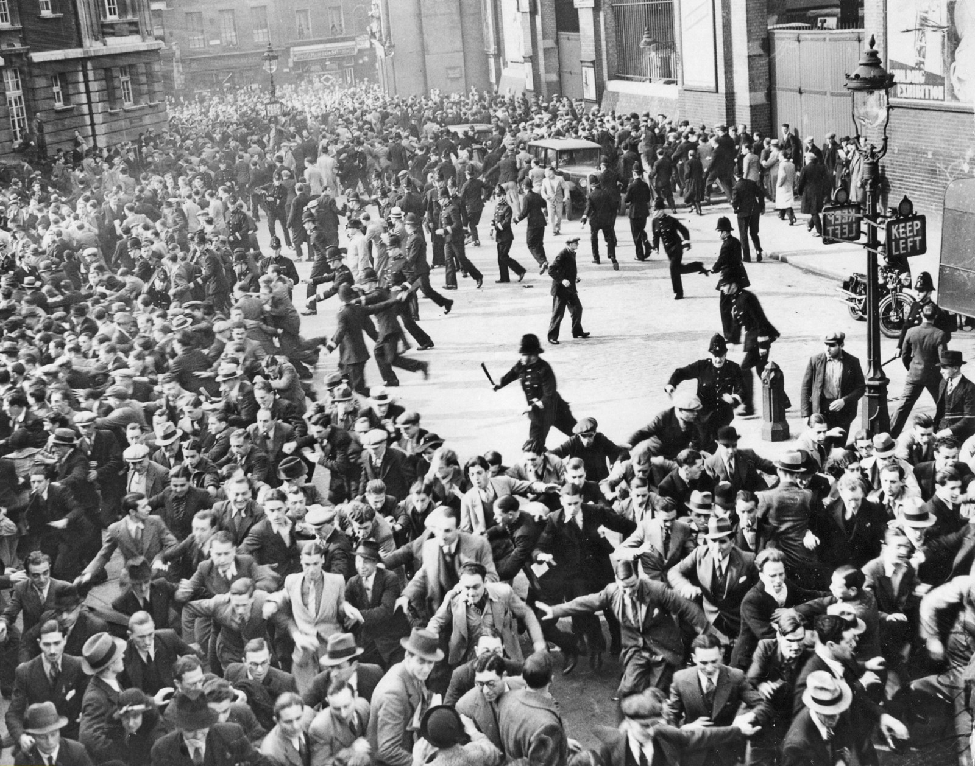
The Battle of Cable Street, London 1936
Around 20,000 anti-Fascist demonstrators, mainly Jewish, Irish, and Communist, turned out to block their way. 6000 police were on the street to protect the march. They, and the Fascists, became engaged in fierce street battles with the protestors, who attacked them with sticks and whatever came to hand. Famously, boys threw marbles under the police horses to trip them up. Women threw vegetables and chamber pots out of their windows at them. People lost their shit, as well they would. You can watch footage of Cable Street here.
The protestors were violent, they broke the law. They stopped the march, and effectively undermined the growth of Fascism in the UK. Interestingly, the romantic notion that it damaged the BUF is now contested by some, but it did lead directly to the Public Order Act of 1936, which banned the wearing of political uniforms, and to that extent slowed the spread of Fascism in the UK as it grew in Europe.
[Contested: "The Battle of Cable Street still holds a proud place in anti-fascist memory, considered a decisive victory against the far right. In fact, the event boosted domestic fascism and antisemitism and made life far more unpleasant for its Jewish victims, explains Daniel Tilles." https://www.historytoday.com/daniel-tilles/myth-cable-street ]
Nobody argues for moral equivalence about the anti-Fascists at Cable Street. Nobody suggests that those opposing the Fascists on Cable Street were in any way equivalent to the Fascist marchers. Nobody suggests that Moseley and his Fascist movement ‘had some good people amongst them.’ There is no moral equivalence. The Fascists were bad, those who took them on were good. In London there are plaques and murals to commemorate the Battle of Cable Street. It was a victory of good over bad. The 20,000 violent, law-breaking protestors are heroes.
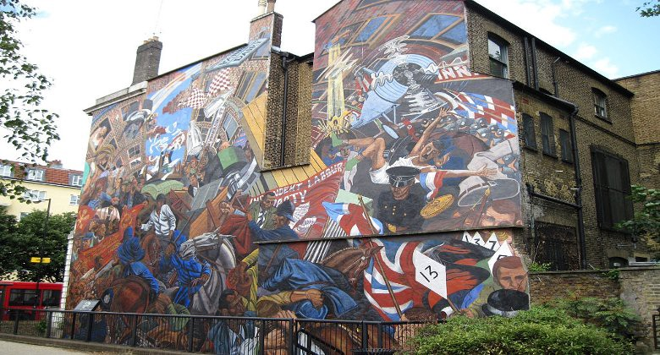
Mural Commemorating the Battle of Cable St, East London (Image: Wikimedia Commons)
The analogy grows fully into the Second World War: there is no suggestion that fighting the Nazis was a bit of an over-reaction. The Nazis were bad. The Allies fought and killed them because they were bad. The war started by the Nazis killed 3 percent of the world’s population, around 60m people. There is nothing good you can say about the Nazis.
With that in mind, anybody who now claims to be a Nazi, or uses Nazi symbols or language, is also bad. They are wrong. This is not a debate about freedom of speech anymore than opposing Hitler’s invasion of Poland was a debate about freedom of movement.
And there is no two sides to Nazis, and those who march under their flags; there is no ‘well some of them are good people’ about it. Nazis are bad. Anyone who says they are a Nazi is bad. Anyone who marches alongside Nazis is bad. There is no feeling sorry for poor white Americans because their plight has led them to become Nazis. You can be poor, dispossessed, and angry without becoming a Nazi. By all means be stupidly racist, embarrassingly anti-Semitic. You are stupid, I disagree with you. But pick up a Nazi flag and you immediately lose any argument you might try to make. You negate any grievance you may have. You are wrong, you are very stupid, and you are bad.
And this time around we have the benefit of hindsight. You could argue that in the 1930s, Germans who joined the Nazi party didn’t yet know what it was going to become. You could (maybe) argue that some Nazis didn’t know what was happening. You could argue people had no choice, and had to march with the Nazis back in 1940s Germany. But this time around is different. We know the Nazis are bad. We know what they did. We know what happens when you let Nazis march down streets. We know what happens when angry white men put on made-up uniforms, buy guns, and march through cities with Swastika flags. [Actually, we don’t.] There is no excuse this time around.
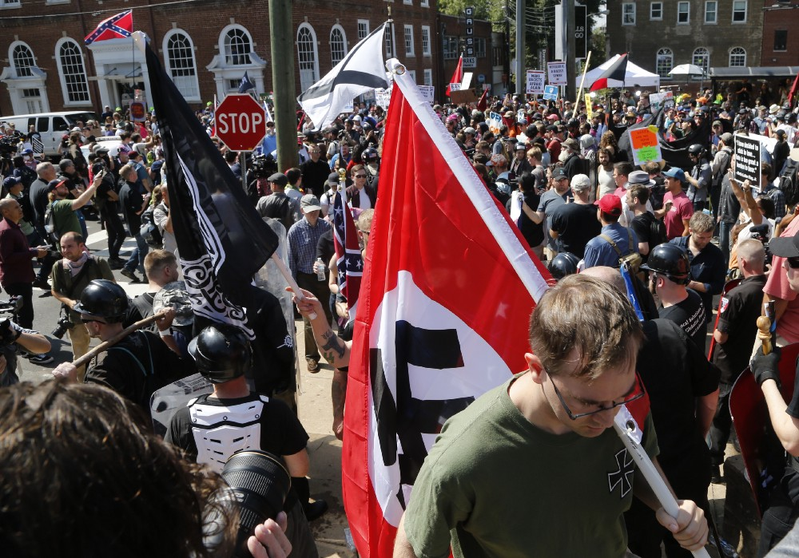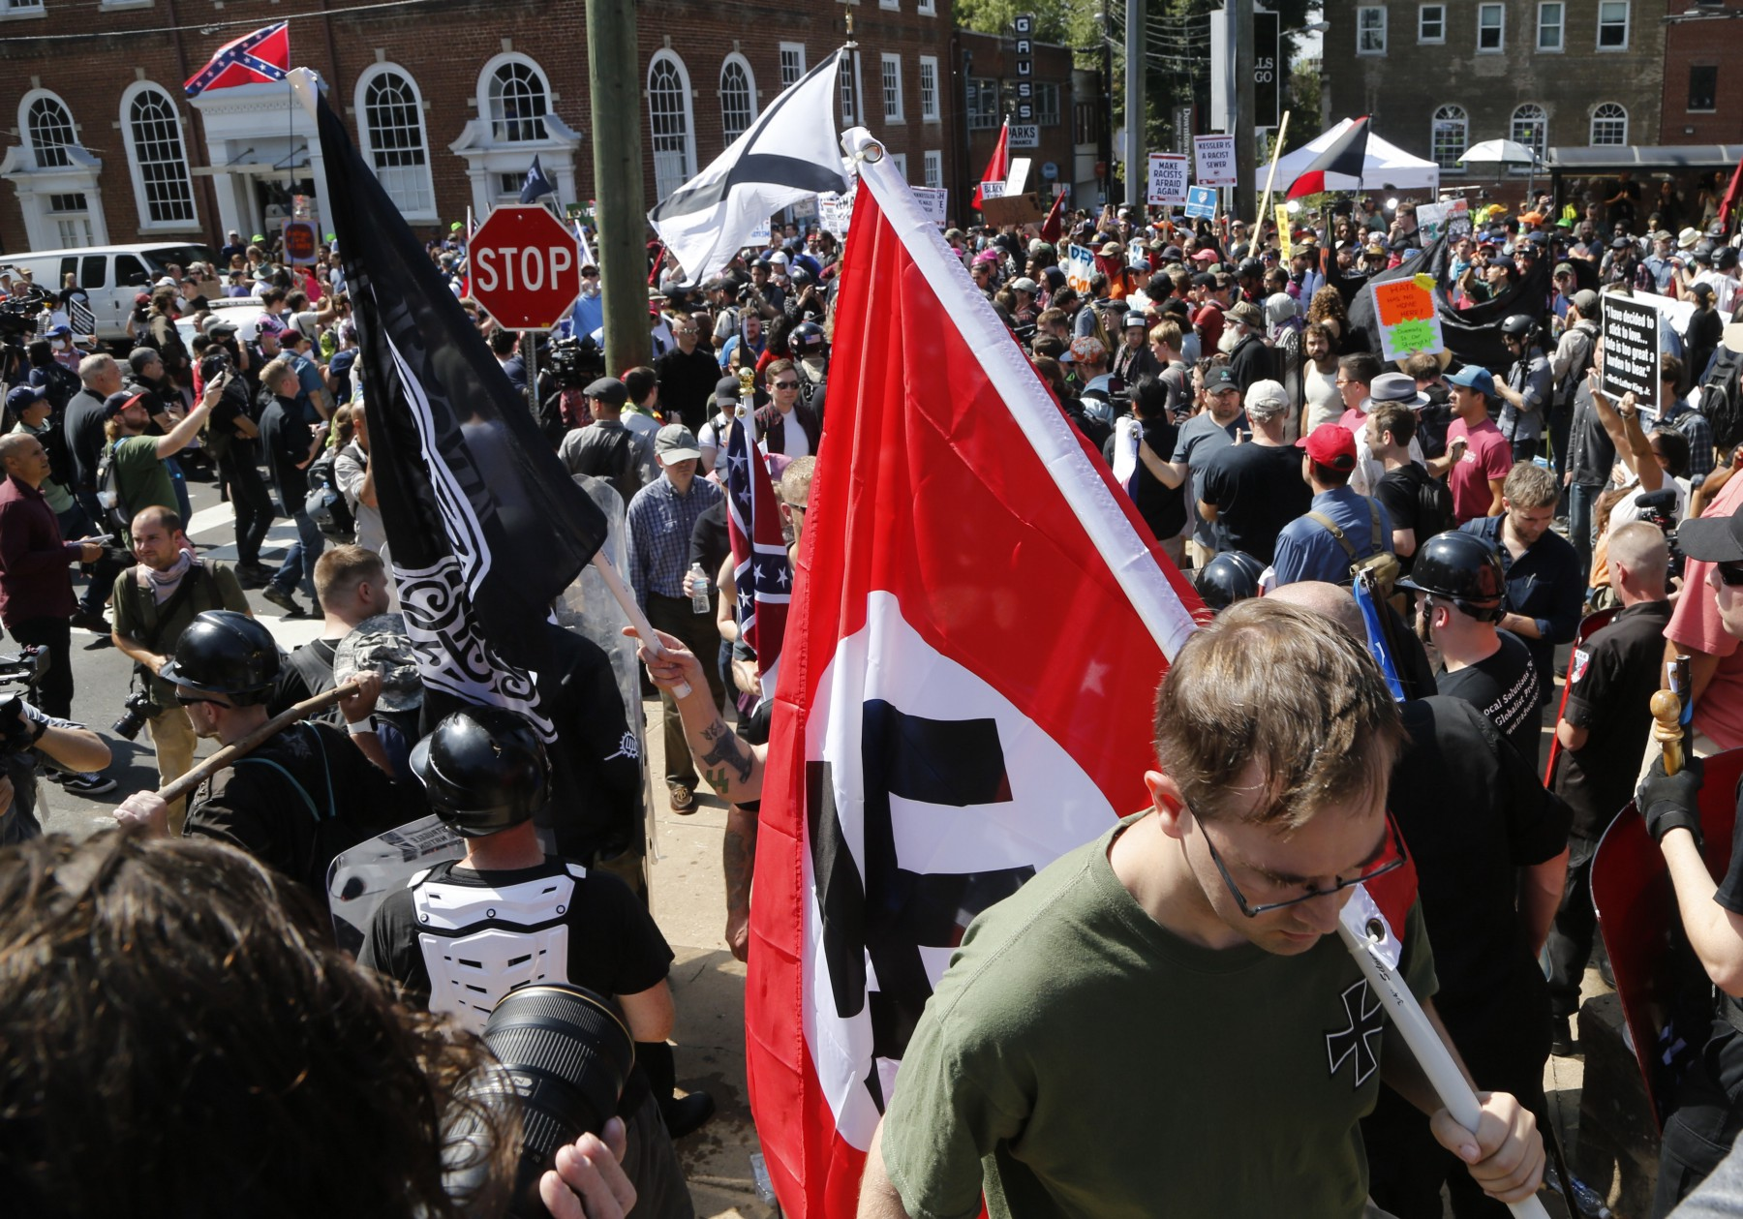
AP Images

The following brilliant sketch by Mitchell & Webb has two Nazi soldiers slowly realising they are ‘the baddies’ because all of their symbols are skulls. Not only is Nazi ideology evil, and based on false science and logic, it led to horrific destruction around the world. Americans who haven’t travelled may not understand this. Perhaps that explains their stupidity in taking up Nazi ideology. Go to any European city, especially Berlin, and you will start to see the concrete buildings that filled in the bomb sites. You will see the memorials, the shrapnel marks on buildings. Nazism was defeated because it was wrong. It was defeated by the sheer force of humanity that opposed it because it was wrong. There is no debate about this. That time passed long ago.
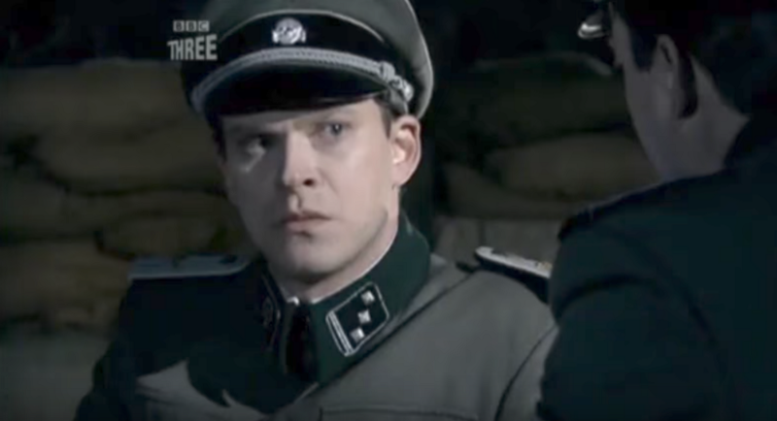
Mitchell & Webb — ‘are we the baddies?’
Europe has its problems with far-right groups. It has neo-Nazi groups. In Europe, wherever we have Nazis, we have loud protest, from people marching on the street to clear uncompromised defiance from political leaders. Neo-Nazi groups are investigated by the intelligence agencies, are tracked like any other extremist terror group.
So, for many Europeans it was shocking to see Americans saluting like the same empty-eyed fools did at Nuremburg. A look of total stupidity and ignorance on their faces, amplified a hundred fold by an outstretched arm. There is no forgiving these people, they are just wrong. It was shocking for Europeans to see people marching under Nazi flags. The Swastika has no place in any context. Anyone associating themselves with a rally in which Swastikas were displayed are just as bad as the worst Nazi in 1930s and 1940s Germany. Trump is wrong that some of the protesters were good people. Nobody can march alongside Nazis without being painted with that same brush. However angry you are, however right-wing you are, if you march in the same protest as Nazis, you are a Nazi. And if you are a Nazi, you are bad and deserve no remorse. Clearly those protestors in Charlottesville combine ignorance with stupidity, picking up the butt-ends of history, construing a semblance of an argument from the ruins of a movement. You can pity them their stupidity, but once they claim to be Nazis, they deserve no pity.
And let’s be clear, for those arguing this a was a protest by the Right opposed by the Left, and both have valid arguments, or both were violent, no, this was a march in which armed men in militia uniforms, carrying Swastika flags, stood outside a synagogue and shouted Zieg Hiel. They organised a march, they took up weapons and flags, they came out on the street. They were opposed by people who reacted to that. Opposing them, vocally, and if necessary aggressively, is justified. Waving Nazi flags outside a synagogue is not about free speech, it is about celebrating an ideology that killed millions of people. It is as good as carrying banners that say ‘mass murder is great.’
Societies have norms; internal sets of rules, accepted collective opinions. Our societies have a lot of these, ranging from abhorring paedophilia, to outlawing murder. If a violent and angry crowd gathered to stop a group of paedophiles from gathering outside a school, very few people would call some sort of moral equivalence, suggesting both sides had a point. The same applies to Nazism. Having right wing views, even being a racist, is unpalatable, but carrying a Swastika and claiming the Nazi ideology is different, and only to be condemned and opposed, along with child abuse, murder, and terrorism.
If you disagree with that, then you are not well informed. You do not know the history of Germany in the 1930s, or the history of the world in the 1940s. You do not understand how a reasonable, civilised, sophisticated country like Germany elected a leader who turned it into a dictatorship, and then turned against ethnic and religious groups to the point that middle-class, otherwise law-abiding people readily murdered women and children with pistols and machine guns, and then automated that killing with gas chambers. We should always be aware of how easily a society can turn, and be willing to shout and kick and fight when we see it heading in that direction, even for a moment.
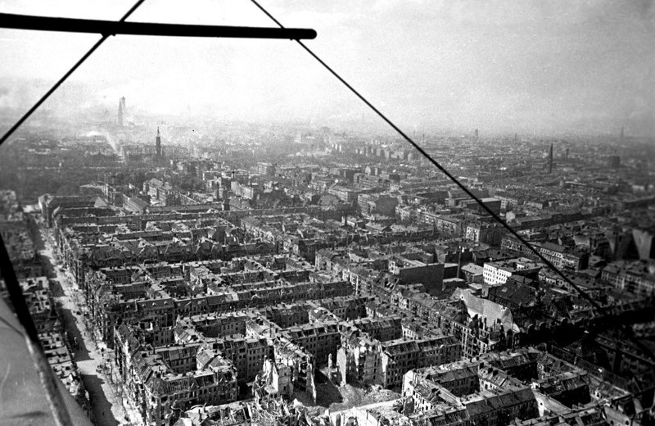
Berlin damaged by war
There is no context in which being a Nazi is OK. If you march under a Nazi flag, you are the person who shot children in a forest, gassed families, and drew the world into a ruinous war. And if you are a Nazi, or you stand with the Nazis, you deserve what the civilised world threw at the Nazis last Century. By taking up that flag, by stretching out your arm, you give up your position in any argument and will just be opposed.
Last century Americans died fighting the Nazis. Young men travelled to Europe to fight an enemy who was not directly threatening their country, to win a war not about their land but because Nazism was evil and wrong. Not because it threatened America, but because it threatened humanity. It threatened everything that is American, what America was founded to be.
Any American who now marches with Nazis marches against what his country is and what his country fought for. And any American who does not immediately and unreservedly condemn a Nazi, is in-American. Not condemning everything about Nazis is to question what happened last Century, to suggest that maybe some of it was right, or justified.
American Nazis and racists are ignorant and stupid. They should be flown to Poland and taken to visit Auschwitz. They should be sat in front of the films of the Camps. (You can watch Hitchcock’s film of Belsen here) They should visit Berlin and see the scars a country bears when the Nazis take control. And any political leader of a country that claims to be civilised and a democracy who does not immediately condemn Nazis in his population should go with them.

